Experiment Details

|  |  |
| --- | --- |
| Department Name | Electronics & Telecommunication |
| Class | B.TECH. |
| Semester | VII |
| Subject Name | RF & Microwave Engineering |
| Experiment No. | 01 |
| Experiment Name | Study of field pattern of various modes inside a rectangular waveguide. |

Version History

|  |  |  |  |  |
| --- | --- | --- | --- | --- |
| Sr. No. | Version Number | Created By | Approved By | Date |
| 1 | v1.0 | Muskan Sameer Vantmori | Mr. Mandar D. Sontakke | 09/10/2020 |
|  |  |  |  |  |

AIM:

Study of field pattern of various modes inside a rectangular waveguide.

THEORY:

Electromagnetic waves propagating in open space travel out in all directions. The power intensity of these waves decreases as the distance increases - it is proportional to the power of the source divided by the square of the distance. The waveguide operates by confining the electromagnetic wave inside a metallic structure so that it does not spread out, and losses resulting from this effect are eliminated. In electromagnetic, the term waveguide may refer to any linear structure that guides electromagnetic waves between two endpoints. Typically a waveguide is thought of as a transmission line comprising a hollow conducting tube, which may be rectangular or circular within which electromagnetic waves are propagated.Signals propagate within the confines of the metallic walls that act as boundaries. The signal is confined by total internal reflection from the walls of the waveguide. Waveguides are used principally at frequencies in the microwave range. Waveguides will only carry or propagate signals above a certain frequency, known as the cut-off frequency. Below this the waveguide is not able to carry the signals. The cut-off frequency of the waveguide depends upon its dimensions.

Rectangular Waveguide

A rectangular waveguide is a hollow metallic tube with a rectangular cross section. The conducting walls of the waveguide confine the electromagnetic fields and thereby guide the electromagnetic wave. The rectangular waveguide is basically characterized by its dimensions i.e., length a and breadth b.

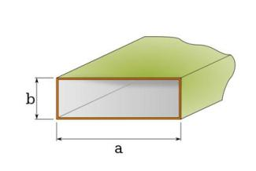

Modes: Electromagnetic waveguides are analyzed by solving Maxwell's equations, or their reduced form, the electromagnetic wave equation, with boundary conditions determined by the properties of the materials and their interfaces. These equations have multiple solutions, or modes, which are eigenfunctions of the equation system. Each mode is therefore characterized by an eigenvalue, which corresponds to a cutoff frequency below which the mode cannot exist in the guide.

Waveguide propagation modes depend on the operating wavelength and polarization and the shape and size of the guide. The modes of the waveguide are typically classified into following types:

TE modes (Transverse Electric) have no electric field component in the direction of propagation.(Ez=0)

TM modes (Transverse Magnetic) have no magnetic field component in the direction of propagation.(Hz=0)

TEM modes (Transverse Electromagnetic) have neither electric nor magnetic field component in the direction of propagation.(Ez=0 and Hz=0)

Field Theory

As we know, an electromagnetic field is comprised of electric and magnetic fields which are perpendicular to each other. These fields have different patterns for each mode. These patterns depend upon the mode numbers (m and n) and the dimensions (a and b) of the waveguide. The electric field and magnetic field pattern are different for various modes in different waveguides. The electric field component of an EM wave is characterized by Ex, Ey and Ez components of the wave.

Similarly the magnetic field component of an EM wave is characterized by Hx, Hy and Hz components of the wave. These components are usually plotted on an XY plane which shows the field pattern for both the fields.

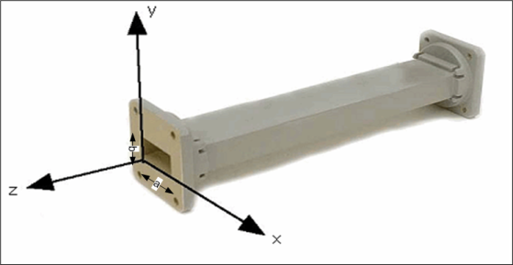

For TEmn mode, the field equations for a rectangular waveguide are:

Ex= (jωµ)/( h2 ) nπ/b cos( mπx/a) sin( nπy/b)

Ey= - (jωµ)/h2 mπ/a sin( mπx/a) cos( nπy/b)

Ez=0

Hx= jβ/h2 mπ/a sin( mπx/a) cos( nπy/b)

Hy= jβ/h2 nπ/b cos( mπx/a) sin( nπy/b)

Hz= cos( mπx/a) cos( nπy/b)

For TMmn mode, the field equations for a rectangular waveguide are:

Ex= - jβ/h2 mπ/a cos( mπx/a) sin( nπy/b)

Ey= - jβ/h2 nπ/b sin( mπx/a) cos( nπy/b)

Ez= sin( mπx/a) sin( nπy/b)

Hx= (jωε)/h2 nπ/b sin( mπx/a) cos( nπy/b)

Hy= - (jωε)/h2 mπ/a cos( mπx/a) sin( nπy/b)

Hz=0

where h=√((mπ/a) 2+ (nπ/b)2) and β= √(ω2µε - h2 )

PRE TEST:

Q.1) A waveguide acts as a,

1) Low pass filter

2) Band pass filter

3) High pass filter

4) All of the above

Answer: 3)

Q.2) Standing waves occurs due to

1) Impedance match

2) Impedance mismatch

3) Reflection

4)Transmission

Answer: 2)

Q.3) Which of the following lines is non-radiating

1) Open two wire

2) Coaxial

3) Both

4) None of the above

Answer: 2)

Q.4) The lines having R, L, C distributed along the circuit are called

1) Lumped

2) Distributed

3) Parallel

4) Paired

Answer: 2)

Q.5) The phenomenon employed in the waveguide operation is  
1) Reflection  
2) Refraction  
3) Total internal reflection  
4) Absorption

Answer: 3)

PROCEDURE:

## Procedure

• Step 1: Select the frequency band in which you wish to see the field pattern.

• Step 2: Select the type of mode, i.e., either Tranverse Electric (TE) or Transverse Magnetic (TM).

• Step 3: Select Pattern:

i) Electric Field: Select this to view the electric field pattern of the given mode.

ii) Magnetic Field : Select this to view the magnetic field pattern of the given mode.

iii) Surface Current: Select this option to view the surface current density for TE10 mode.

• Step 4: Enter the values of m and n to obtain the field pattern, where m stands for no.of half waves of electric or magnetic intensity in the X- direction, and n stands for number of half waves in the y direction if the propagation of wave is in z direction.

• Step 5: Run the VI up to see the desired field pattern in XY, YZ and XZ planes. In case, you wish to see the other field pattern then click stop and repeat steps 1-4 before running the program again.

You may see the the following example for your reference, where appropriate buttons are selected in order to observe **the electric field pattern**of TE10 mode in X-band:

### Enter the frequency in GHz

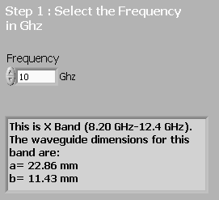

### Select Mode (TE/TM)

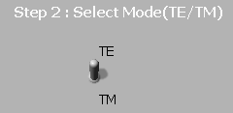

### Select pattern

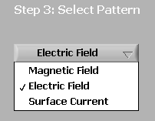

### Select value of mode numbers m and n



### View the pattern

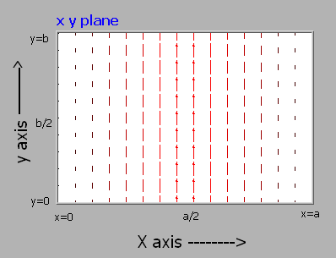  
  
  
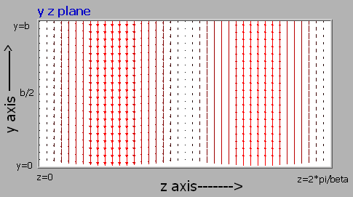  
  
  
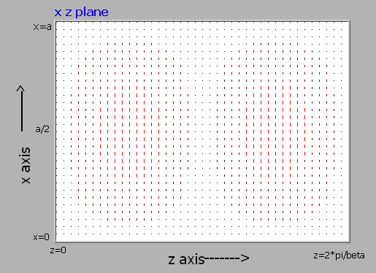

POST TEST:

Q.1) In which mode of rectangular waveguide are all field components zero?

1) TM00

2) TM11

3) TM01

4) TM10

Answer: 1)

Q.2) Which mode has the minimum cutoff frequency in rectangular wave guides?

1) TE11

2) TE10

3) TE01

4) TE20

Answer: 2)

Q.3) In TM mode, what is the first propagating mode?

1) TM01 mode

2) TM11 mode

3) TM12 mode

4) TM10 mode

Answer: 1)

Q.4) TEₒₒ mode for a rectangular waveguide:

1) Exists

2) Exists but defined only under special cases

3) Does not exist

4) Cannot be determined

Answer: 3)

Q.5) At a frequency equal to cutoff frequency in a rectangular wave guide

1) the flow of electromagnetic energy is zero

2) the flow of electromagnetic energy is infinite

3) the flow of electromagnetic energy is 50% of maximum

4) the flow of electromagnetic energy is 10% of maximum

Answer: 2)

REFERENCES:

• Microwave Devices and Circuits", Third Edition, Samuel Y.Liao

• "Field and Wave Electromagnetics", Second Edition, David K.Cheng

• "Electromagnetic Waves and Radiating System", Second Edition, Edward C.Jordan, Keith G.Balmain